Secretary
Papri Sarkar, MD
Director
Brookline Dermatology Associates
235 Cypress Street, Suite 200, Brookline, MA 02445
617-277-0800 Phone
617-582-6060 Fax
papri01@gmail.com

Tax ID 04-6123550

Dear Colleague:

Thank you for your interest in becoming a member of the New England Dermatological Society (NEDS). To begin the application process, please submit an application which is available as a hard copy (attached) or on our website www.nederm.org, along with a $225 application fee that will cover your dues for the first year of membership. To complete your application, you will also need to submit a letter of reference from Active NEDS member (template attached).

The New England Dermatological Society offers a 50% discount on the first year’s membership dues for any person who applies within one year of completing residency or fellowship training. The Society also offers a $50 rebate on membership dues to any member who refers a new member to the Society.

Your application will be reviewed at the next scheduled council meeting when all necessary information is received.

If you should have any questions please feel free to contact our Administrator by telephone at (781) 434-7731 or e-mail at neds@mms.org .

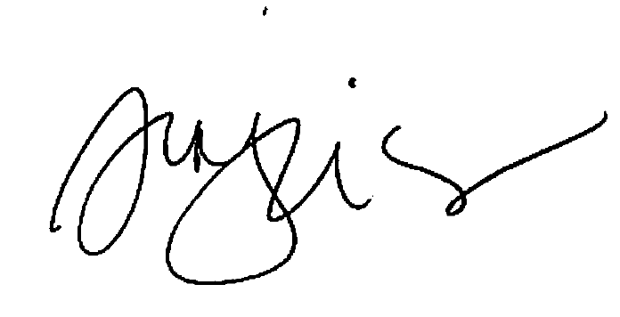

Papri Sarkar, MD
Secretary, New England Dermatological Society

NEDS Membership Application

Full Name:

Referred by:

Home Address: Office Address:

Office Phone: Office Fax:
Email address:

Date of Birth: / /

Place of Birth: / /

Citizen of U.S.A.?
If no, citizen of

How long have you practiced at the present address?

I hereby apply for the following membership category (check one):

Active Board certified by the American Board of Dermatology
Associate Completed 3 years of training in dermatology but not board certified
Affiliate Non-dermatologists with dermatology related specialty (i.e. researcher, pathology-trained
dermatopathologist)
Adjunct Nurse practitioners and physician assistants who work under the supervision of an active
member

If applying for Active membership, year when board-certified in dermatology:

Please list other board-certifications:
Year:

Year:

Year:

Year:

If applying for Adjunct membership, please fill out this section:

Check one: Nurse Practitioner:

Physician Assistant:

Please name your supervising Dermatologist: Length of time working with the above Dermatologist:
What portion of your practice is devoted to seeing dermatology patients? %

If not 100%, how is your other time spent?

Training and Education (complete all that apply) OR Attach your CV
1. Undergraduate:

Degree:
Year completed:

School: Location:

2. Graduate:

Degree:

Year completed:

School: Location:

3. Additional Graduate:
Degree:
School: Location:

4. Internship and Residency:
Specialty: Year completed:

Location:

Specialty: Year completed:

Location:

Specialty: Year completed: Location:

5. Fellowship training:
Specialty: Year completed:

Location:

Specialty: Year completed:

Location:

Present hospital positions held (do not list courtesy affiliations):

Present teaching positions held:

Medical Society memberships:

Areas of interest / expertise:

Publications:

List one Active member who will send letters of endorsement on your behalf:

1.

Please return your application, payment and letter of endorsement to the following address:

NEDS Administrator
New England Dermatological Society
P.O. Box 549127
Waltham, MA 02454-9127
neds@mms.org
781-464-4896 Fax

Application Fee: The $225 application fee is applied toward your first year of membership dues. If not paying by credit card, please forward a check payable to “New England Dermatological Society” to the address above.

Signature:

Date:

TO: NEDS Administrator
New England Dermatological Society
PO Box 549127
Waltham, MA 02454-9127
neds@mms.org
781-464-4896 Fax

Dear Administrator:

I would like to recommend

Name & Suffix
for membership in the New

England Dermatological Society. As a well-trained and competent dermatologist, s/he would be an asset to our society.

Sincerely,

Signature

Printed Name

